Bridge Task Documentation
By: Reza Ferrydiansyah

Table of Contents

1 Introduction 2
2 Main features of a BT 3
3 LON CAPA .task format 4
3.1 Header Information 4
3.2 Variables and Parameters 5
3.3 Questions and Criteria 6
3.4 Finishing up 9
4 Using the colorful editor 9
4.1 Creating variables 9
4.2 Creating Questions 10
4.3 Criteria 10
4.4 Finishing up 10
5 Setting Up the Bridge Task in a Course 10
6 Creating Conditional Sequences 11
7 Slots 12
7.1 Adding Slot Using the Interface 12
7.1.1 Required Slot Attributes 12
7.1.2 Optional Slot Attributes 12
7.1.3 Selecting Resource Available Within Slots 13
7.1.4 Specifying Proctors 13
7.1.5 Specifying Users 13
7.2 Uploading Slot Files 13
7.2.1 Specifying Types of Input Fields 13
7.3 Editing and Deleting Slots 15
8 Uploading Files Using Portfolio 15
9 XML 15
9.1 Elements 16
9.2 Attributes 16
9.3 Headers and Root Element 16

Introduction
BTs or Bridge Tasks are open-ended, performance-based assessments. BTs are based on a mastery-model of assessment and evaluated on a pass-fail basis. You may use BTs in a variety of ways, from supporting the scoring of a final project, to individual lab assignments.

Bridge tasks consist of one or more individual tasks that describe what the student is to do, usually in the form of a problem to solve. LON-CAPA supports the creation of multiple versions of each task, so that each student may receive a mix of randomly assigned tasks to perform. Students use LON-CAPA to view the bridge task. LON-CAPA supports the scheduling of BTs to restrict access by IP address range and to allow students to schedule slots of time to take a BT.

When students complete a BT, they upload files they have created for grading. Files are uploaded using LON-CAPA’s portfolio system.

LON-CAPA supports the creation of scoring rubrics associated with each individual task to guide graders and ensure inter-rater reliability among multiple graders in a course. Instructors specify criteria to assign an overall score to a BT based on the scores of the individual rubrics.

BTs are used in Michigan State University’s CSE 101 course. The course is designed to teach computer competencies by having students solve problems using a variety of computer software (MS-Word, MS-Excel, World Wide Web, and MS Access). In CSE 101, BTs are used for summative assessment, the majority of students’ grades are based upon the BTs. Here, students must successfully pass a BT before attempting the next BT. A student’s final course grade is based on the highest level BT passed. The CSE 101 class is quite large, approximately 2000 students per semester. Students may take up to one BT per week; typically there are over 14,000 BTs administered per semester. Thus there is a need to quickly and accurately access students. LON-CAPA successfully supports the load requirements.

This document describes how to create a bridge task in LON-CAPA. Section 2 takes the readers on a description of the main features of a BT. A work flow of the BT creation process is given in figure 1. Section 3 describes the creation of a Bridge Task using the LON-CAPA native .task language method. The sections after that discusses the administrative aspects of Bridge Tasks, this includes determining how to use bridge task (Section 4) which Bridge Tasks to show to the students (Section 5) as well as determining when and where students may take Bridge Tasks (Section 6). Following that is a section on handing in files using the portfolio. The final two sections is a reference section on XML.

Main features of a BT
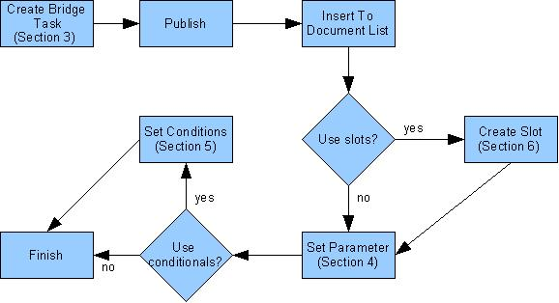
Figure 1: The bridge task creation process flowchart

There are many ways in which BTs differ from other assessments.

- Multiple Versions. There are multiple versions of a BT. A person taking a BT may receive a different version than the person taking the same BT sitting next to him or her. To create BTs that have different versions, the instructors who created the BT will create multiple sub-questions. The BT engine then chooses one of the sub questions and gives that sub question to the student, thus creating multiple versions.
- Essay/task based. Bridge task questions open-ended. Users create files which they upload and submit to the system.
- Rubric-Based Grading. Each question in a bridge task has scoring rubrics, criteria, associated with them. These criteria are used as the basis of grading. The grading page provides the criteria checklist on which the grader enters whether a student passes or fails each criterion. This ensures inter-rater reliability among multiple graders.
- Mandatory and Optional Criteria. Some criteria can be made mandatory, that is a student will fail if the student does not pass that criteria. Some criteria are optional and the student must pass a certain number of these optional criteria. Criteria are associated with questions, which can also be made optional or mandatory. The LON-CAPA calculates whether a student has passed or fail based on the number of mandatory and optional questions the student has passed.
- Automatic Bookkeeping. The system calculates whether the student has passed a BT or not and records it into the database. The system stores
- a complete record of the BT each student received
- when each student’s BT was administered
- the BT instance
- the files the student turned in
- the associated grading criteria
- the grading results (and history of grading, including grader ID)
- Sequential Bridge Tasks. The system can be set in such a way that a student can only take a certain bridge task after passing the previous bridge task on the list. This is done using conditionals in LON-CAPA. There are other ways to use conditionals and bridge tasks to customize the usage of bridge tasks in a course.
- Slots. Slots can be created to relate students with time and location. This allows control of where and when a student can take a bridge task.
- Proctor Authentication. Slots also allow a particular proctor to be in a particular location for a bridge task. Each student who is scheduled to take the bridge task must be authenticated by the proctor.

LON CAPA .task format
The LON CAPA .task format is an XML file used directly by LON CAPA. XML is a markup language, much like HTML. A primer on XML is given in section 9 . An XML file contains elements in tags, and elements may contain attributes. The syntax, spelling (including capitalization) of the XML file must be exact, otherwise the XML file will generate errors.

The online editor for the .task format is discussed in the next section. This section describes creating the .task file by simply using a text editor such as Notepad.
In this section the elements of this file is described. The .task format consists of three parts:
- The header, which contains information about the file itself. The header can be copied from this documentation as is.
- Parameter information. This part consists of the possible values for various parameters in the Bridge Task.
- Questions section. This part consists of the actual text the user sees as well as all criteria and questions.

Header Information
The root node of the .task format is the task element, which is an XML element written as follows:
<Task OptionalRequired="0">
The Task element signifies that this is a bridge task. The OptionalRequired is a mandatory attribute, and the value (0 in this case) determines how many optional questions must the student get correctly. In most cases, the value of the OptionalRequired attribute for the top level Task element is 0.

Variables and Parameters
To create difference versions of Bridge Tasks for each student, parts of the questions are defined using variables. Each variable contains multiple instances of possible values and LON-CAPA randomly selects an instance to give to the student.
All variables are placed inside a Setup element. Each setup element has an id attribute which contains the name of the variable. The possible instances or values of those variables are placed inside the setup element inside an Instance tag. Each Instance element has two mandatory attributes, the OptionalRequired attribute which should be set to 0, and the unique id of that instance. The value of the id attribute can be any text as long as it is unique throughout the document.
The actual data of the instance is placed inside InstanceText tags. Currently the instance data is created with a loncapa/perl script. In this script, the parameters of the variable are set. The syntax to set the parameter of a variable is ‘$variableName {fieldname} = “fieldValue”’. The variable name is taken from the attribute id from the Setup element, thefield name is the name of the parameter the author sets, and the fieldValue is simply the value of the field. The first parameter that must be set is the instance field, with the value being an identifier of the instance.
The example below shows a portion of the bridge task XML file. This portion should be placed inside the task element :

<Setup id=”entitySubject”>
<Instance OptionalRequired=”0” id=”instanceHarry”>
<InstanceText>
<script type='loncapa/perl'>
$entitySubject{instance} = “instanceHarry”;
$entitySubject{personname} = “Harry”;
$entitySubject{place} = “zoo”;

</script>
</InstanceText>
</Instance>

<Instance OptionalRequired=”0” id=”instanceBetty”>
<InstanceText>
<script type='loncapa/perl'>
$entitySubject{instance} = “instanceBetty”;
$entitySubject{personname} = “Betty”;
$entitySubject{place} = “park”;

</script>
</InstanceText>
</Instance>

</Setup>
The example above describes a variable question. It has two different possible values for the entity “subject”, Harry and zoo or Betty and park. Variables can be placed inside the questions by using the variable name and field name.
The first line <Setup id=”entitySubject”> marks the start of the setting up of the variable. In this case, the variable is named entitySubject (based on the id attribute of this line.
The first instance of this variable is shown between line 2 to 10. Line two <Instance OptionalRequired=”0” id=”instanceHarry”> marks the beginning of the instance element named instanceHarry (based on the id attribute). The OptionalRequired is given a value of 0. Line 3-9 determines the actual value of this variable. Line 5-7 defines the instance properties, which must be of the form $<variable name>{<property_name>} = <value>. The first line of the property must be the instance property (see line 5 of example), with the value being the id of the instance. Other lines (6-7) can be used for any attributes. All other lines (3, 4, 8, and 9) must be typed as such.
Line 12-21 shows the second instance with the same rules as the first instance. Line 23 </Setup> gives the closing Setup tag which must be written precisely.

The example of the usage of this variable inside the question is this text: :
This is a test question. $entitySubject{personname}
went to the $entitySubject{place}. .

The LON-CAPA engine will replace any instance of $<variable_name> (<property_name>) with the correct value, depending on the randomly chosen instance.

Based on this code, two different questions are possible:
- This is a test question. Harry went to the zoo
- This is a test question. Betty went to the park

Questions and Criteria

The task description should be divided into questions. Questions can also be divided into sub-questions. A question or sub-question must have one or more criteria that are the scoring rubrics used to evaluate that question. A task may also have a criteria. Graders use these criteria to evaluate student work Both questions and criteria are interspersed within the task description, placed where students see them when reviewing their graded bridge task.
Questions are created by using the Question tag. Each question must have a unique id attribute which identifies the question, the value of the id attribute is any text that is unique in the document. Each question must also have the Mandatory attribute which can be set to “Y” if the question is mandatory or “N” otherwise. Finally the question may also have a OptionalRequired attribute, which determines how many optional criteria students must pass to pass the question.
The question element will have the actual text of the question. The questions are created inside the QuestionText element. The question descriptions are placed inside the file by simply typing the text. The text can be marked up to have various formatting. The mark up language used is simple HTML.
Criteria are created using the Criteria tag. The attributes for the criteria tag are similar to the attributes for the questions tag. Criteria tags have id attributes as well as Mandatory attributes. Like for the question tag, the value of the id attribute is any text that is unique in the document, and the Mandatory attribute (values “Y” or “N”) determines whether the criteria is mandatory or not. Criteria tags do not have OptionalRequired attributes. The criteria description is created inside the CriteriaText element and can be formatted the same way as the formatting of the questions (using HTML).

<Question id=’q.testquestion’ Mandatory='Y' OptionalRequired=’1’>
<QuestionText>
Some test explanation
<Criteria id=’criteria.overall.handin’ Mandatory=’Y’>
<CriteriaText>
Criteria text 1
<GraderNote>
This part cannot be seen by students but is used to give additional info to the grader to help evaluating the criteria.
</GraderNote>
</CriteriaText>
</Criteria>

<Question Mandatory='N' id=’q.question1’ OptionalRequired=’0’>
<QuestionText>
The actual test question
<Criteria id=’criteria.question1’ Mandatory=’Y’>
<CriteriaText>
Criteria text 2
</CriteriaText>
</Criteria>
</QuestionText>
</Question>

Instructions to the student on submitting files
</QuestionText>
</Question>

The question that the students will see is:
Some test explanation
The actual test question
Instructions to the student on submitting files

Any text inside a QuestionText element (lines 2, 14) and not inside a criteria element will be shown to the users. This example has one question, and one optional sub-question. The question element is given in line 1, the id of the question being 'q.testquestion', it is a mandatory question (Mandatory='Y') and it requires that 1 optional question/criteria be passed (OptionalRequired='1'). The sub-question is given in line 13, named 'q.question1', is not mandatory and has no optional questions or criteria that is required to be correctly answered.

The example above shows a code for the creation of criteria. There are 2 criteria in the above question (line 4 and 16). Each criteria has a name (criteria.question1 and criteria.overall.handin) which are both mandatory (the attribute Mandatory is set to 'Y'). The text of the criteria is given inside the CriteriaText element inside each CriteriaElement. The student will never see the criteria when the student is taking the test. The grader will see this on his/her screen:

Criteria text 1. Grader Note: This part cannot be seen by the students but is used to give additional info to the grader to help evaluating the criteria.
ο Pass ο Fail
Comment:

Criteria text 2.
ο Pass ο Fail
Comment:

When the bridge task is graded the student will see both the questions and the criteria in his space. Anything inside the GraderNote element (line 7) is not shown to the student.
Some test explanation
Criteria text 1
Pass
The actual test question
Criteria text 2.
Pass
Instructions to the student on submitting files

Finishing up
Once all questions are written, the file must be closed with the </Task> tag. The file must be saved with a .task extension then placed into a LON CAPA author's folder. To upload the file simply go to the construction space and simply upload the new file using the upload new document button. Once the file is uploaded to LON CAPA, the author can publish the file so that the domain coordinator will be able to use the file. To do this select publish (or re-publish) in the select action combo box next to the file name.

Using the colorful editor
Another way of creating Bridge Task is via the colorful editor. The colorful editor allows authors to create resources (including Bridge Tasks) online. The basic idea of the colorful editor is you insert and delete different type of sections into your file to build the bridge task.

If a task file has already been created, then click on the file name, and click on the “Edit” button to open the file in the colorful editor. If a task file needs to be created, enter the file name in the area “Create a new directory or LON-CAPA document” with the combo box at the left of this set to “New File”. At the second screen, press continue to create a new task. At the third screen, select the blank task template and press the “Create task” button to create this blank task. To go into the colorful editor, press the “Edit” Button.

Creating variables

To create difference versions of Bridge Tasks for each student, parts of the questions are defined using variables. Each variable contains multiple instances of possible values and LON-CAPA randomly selects an instance to give to the student. Figure 2 shows a screenshot of this process.

To create a variable, choose “Setup ...” in the insert pull-down menu (circled 1 in figure). Press the Submit Changes and Edit just above the work space. A new box should appear with the label “Setup ...”. In this box, fill out the id box (circled 2) with any text that is unique to unique to the document. This id is the name of the variable and will be used when creating the values for the variable.

The setup box has an insert pull-down menu next to the label (circled 3), select “Specific Question Instance” in this pull down menu, then again press the Submit Changes and Edit button. This creates one single instance of a set of possible values. For each instance created, a new “Specific Question Instance” must be created. Right now a box should appear inside the “Setup... “ box with the label “Specific Question Instance”. Insert a unique id for that instance which can be any unique text (circled 5). This id is the instance name and is used as one of the property of the variable.

In the question instance block, select “Information for the Instance” in the insert pull down (circled 4). Again press submit button. A new text block should appear. In this text box, a perl script will be created (circled 6). The first line to be inserted is the text <script type='loncapa/perl'>. This is followed by the set of parameters for this variable. The syntax to set the parameter of a variable is ‘$variableName {fieldname} = “fieldValue”’. The variable name is taken from the id field of the Setup block, thefield name is the name of the parameter the author sets, and the fieldValue is simply the value of the field. The first parameter that must be set is the instance field, with the value being an identifier of the instance (which is the id of the specific question instance block). The input should end with the text </script>
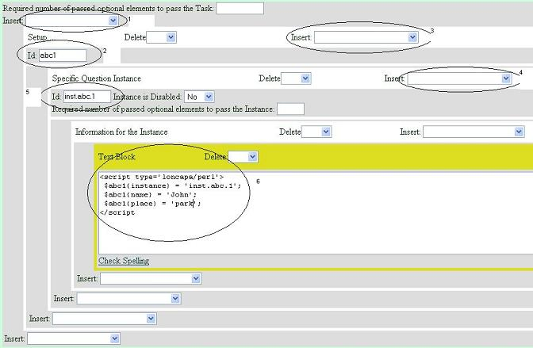
Figure 2: Screenshot of creating a setup

The example below shows two instances of this script for the variable entitySubject with two instances, 'instanceHarry' and 'instanceBetty'.

The first instance (instanceHarry) is:
<script type='loncapa/perl'>
$entitySubject{instance} = “instanceHarry”;
$entitySubject{personname} = “Harry”;
$entitySubject{place} = “zoo”;
</script>

The second instance (instanceBetty) is:
<script type='loncapa/perl'>
$entitySubject{instance} = “instanceBetty”;
$entitySubject{personname} = “Betty”;
$entitySubject{place} = “park”;

</script>

The example above describes a variable question. It has two different possible values for the entity “subject”, Harry and zoo or Betty and park. Variables can be placed inside the questions by using the variable name and field name.
The example of the usage of this variable inside the question is this text: :
This is a test question. $entitySubject{personname}
went to the $entitySubject{place}. .

The LON-CAPA engine will replace any instance of $<variable_name> (<property_name>) with the correct value, depending on the randomly chosen instance.

Based on this code, two different questions are possible:
- This is a test question. Harry went to the zoo
- This is a test question. Betty went to the park

Creating Questions and Criteria
The task description should be divided into questions. Questions can also be divided into sub-questions. A question or sub-question must have one or more criteria that are the scoring rubrics used to evaluate that question. A task may also have a criteria. Graders use these criteria to evaluate student work Both questions and criteria are interspersed within the task description, placed where students see them when reviewing their graded bridge task.
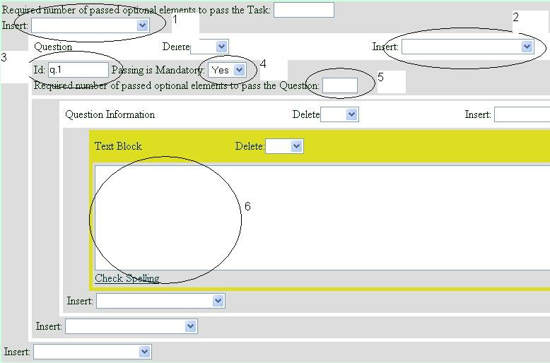
Figure 3: Screenshot of question creation page
Figure 3 shows a screenshot of the question creation page. To create a question, first select “Question” in the main insert pull-down (circled as 1). In this question create a unique id which can be any kind of text (in circle 3). You can also set whether a student must pass this question by setting the value of “Passing is Mandatory” to “yes” (circle 4) or whether this question is optional by setting the value to “no”. You can also set the number of optional subquestions/criteria that the students must get correct in order to pass this question.
Once that is set up create the question information by choosing Question information in the insert pull-down (circled as 2) and pressing the submit button. A text box should appear (circle 6) and you can insert any text in this text box. Anything that is typed in this text box will appear to the student as part of the question. HTML tags can also be used to format the text in the text box. Subquestions can be added by inserting a new question (circle 2).
To add a criteria, instead of choosing “Question” in the insert pull down, select “Question Criteria” (circled as 1). Pressing the submit button will bring up the Question criteria as well as the criteria information where you can write the criteria (Figure 4). The criteria is shown to the student only when the student is reading his/her feedback. The criteria is also shown to the grader in order for the grader to be able to grade the student submission.

In the criteria block, first create a unique id for this criteria (any text) (circle 1). You can also specify whether a criteria is mandatory or not, this is set in the Passing is mandatory pull-down similar to that of the question (circle 2). Text in the text block (circle 4) is shown as the criteria. The text can be formatted with HTML. You can also insert a grader note which will only be shown to the user. To do this select “Text to display to grader” in the insert pull down menu of circle number 3.

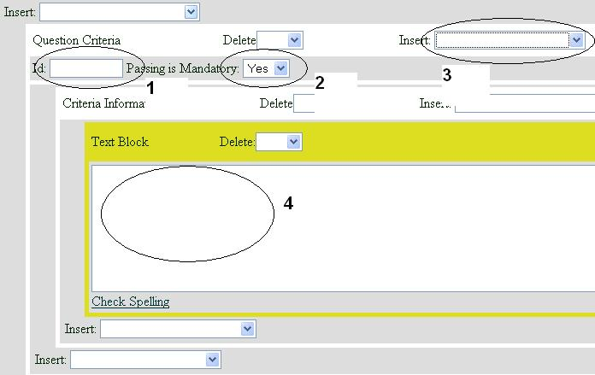
Figure 4: Screen shot for criteria creation

Finishing up
Once the construction is complete, the author can publish the file so that the domain coordinator will be able to use the file. To do this select publish (or re-publish) in the select action combo box next to the file name.

Setting Up the Bridge Task in a Course
The first step in making bridge tasks available to students is to include it in the document space. To do this, first enter the course coordinator space for the course, go to "Course Documents" and click on import. This page gives the list of files that you have created. Select the bridge task and press import to insert the file to the list of documents. After importing the document, you must re-initialize the course.

Now the assignment is in the list of documents, but it is not available for students. There are two ways of making bridge tasks available to students. One method is by using slots (the default method), which restrict the bridge task document to open at certain time/place only. The other method allows students to take bridge task like any other Lon-CAPA assignments, that is at any time they want within opening and closing dates. This method does not restrict the access to particular computers or rooms. Any student in the course may open the BT.

If you want to use slots, first create the slots as described in section 7 . Once the BT is imported (and slots are created) go back to the document list and click on the bridge task resource, this should take you to a page that shows the resource content. If you are not using slots, click on the bridge task resource. Next, (whether you are or you are not using slots) click on PPRM (a button on the top menu) to modify parameters for this resource.
Set the opening date and the due date (if any) in the for resource column. To do this, click on the * in the in course for resource column. A pop up should appear. Enter the date you want the resource to be available and click the store link.

If you are using slots:
- Change the "Use slot based access controls" parameter to "Yes".
- Change the "Slots of availability" parameter" for the course in for resource column to the name of the slot that you created. You may need to change the input type (the combo box at the top of the popup) to 'String Value' instead of 'default'.

If you are not using slots:
- Change the "Use slot based access controls" parameter to "no" by clicking on the * in the for resource column
The bridge task should now be available to students. To see the BT in the student view, switch to a student role in your course. Navigate contents and click on the resource.

Creating Conditional Sequences
It is possible to configure bridge tasks such that only when a student passes a Bridge Task does the next Bridge Task appear to the student. This feature is useful in such cases as Bridge Tasks are related to one another, and the results of one Bridge Task is needed for the next Bridge Task.

To create configure bridge tasks these way, a sequence page must be created. A resource author starts at his/her construction space (Main menu -> CSTR). Once in the construction space, the author create a new assembled sequence.

The author must create various conditionals to determine which resources to show. The easiest way to do this is by using advanced edit. The advanced edit visualizes the various conditions and resources. This interface needs popups, so make sure popups are enabled in the browser.

In the main starting view of the advanced edit, there are two squares, marked start and end respectively. Start by creating a link between the start square and the end square. To do this click on the start square (on the row under the text start), select "Link Resource", then click on the end square. A link is now created between the start and the end boxes.

Once a link is created the author adds resources and conditions. Click on the link and then choose insert resource into link. This allows the placement of a resource such as a bridge task into the sequence. Once the resource is placed into the link, the author should create a mapalias. To do this, select the resource, then click on set parameters, and change the value of Custom Parameter to an alias.

Under each square is an area of the same color as the square, these areas can be used to create conditionals to get to the next resource to the sequence. This document only discusses using conditionals to block access to the next resource (including Bridge Tasks).

Add conditionals by clicking on the area just under the squares. A popup window will appear with a condition box and some options. The condition box allows the author to enter a variety of different conditions. To block access to the next resource, select the second option "Blocking this link if false".

The conditions used will be :
&EXT('user.resource.resource.0.awarded','<alias of resource>') eq '1'
<alias of resource> should be changed to the alias set for the previous resource that the student needs to pass before the next resource is unblocked. If the student has not passed a particular homework/problem/bridge task, the value of user.resource.resource.0.awarded is 0 otherwise the value is 1. This line checks whether the value of user.resource.resource.0.awarded for that resource is equals to 1, if not the link is blocked and the next resources are not shown to the user.

Slots
To restrict the when and where BT's can be taken, the slots feature of Lon-Capa is used. Slots allow the instructors to specify the room, the time, the students that can take the Bridge Tasks, and finally any proctors that will authenticate the students.

A course coordinator can add slots, by pressing Managing Parameters on the main menu and then clicking on the link Managing Slots. The link will take the user to a page showing all available slots. The user can control which slots to show based on opening date, as well as what slot information to show.

There are two ways of creating slot, using the web interface in LON CAPA and uploading a comma delimited file. Uploading a file allows the coordinator to use other applications in creating the comma delimited file and automate the entry of multiple slots. The following text is taken from the LON CAPA course manual.

Adding Slot Using the Interface
One way to add new slots is by using the LON-CAPA interface for adding slots. This is
simply done by pressing the Create a New Slot button.

Required Slot Attributes
In the first page, input an identifier (name) for this slot. The identifier must be unique, and it must be one word without any special characters. You must also specify the time the slot is open by setting the starting time and the ending time.

Finally, you must specify whether this slot is instructor assignable or student selectable. Instructor assignable means that the instructors select which students go to which slots, while student selectable means that students can choose from a number of slots that they schedule themselves in.

Optional Slot Attributes
Once the required attributes are selected, you press next to get to the next page. The next page shows the various optional attributes available. One attribute that you can set is whether a proctor is needed for authentication. If a proctor is needed for authentication, the proctor must put a username and password into the student’s resource page in order for the student to see the resource.

If you had chosen student selectable, you can also set the time the students will be able to apply for the slots. The maximum capacity for each slot can also be set which restrict the number of students per slot. Finally, you can set that for a particular time period, a student may only apply for one slot. This is mainly used to limit the number of times a student may use this resource.

Finally it is possible to limit the computers that are allowed to open the resource by setting the ip address range allowed. By setting this, you can set that a slot can only be opened from a particular room.\

Selecting Resource Available Within Slots
You can also specify which resources/files can a student open during the slot time. To do this, you must set that the slot is restricted to a specific resource (on the optionalattributes page). When this option is selected, the next page allows you to choose which resource this slot is restricted to.

Specifying Proctors
If you set that a proctor is needed for authentication. You will get a screen that allows you to set a valid proctor for that slot. Select proctor by checking the checkbox next to their names. The select and unselect button checks or unchecks the checkbox depending on the person’s group.

Specifying Users
The next screen allows the instructor to restrict the person who can use the resource. There are many ways to select persons who may use the resource. You can individually select each person, you can select the groups, the role, or by the sections that they are enrolled in.

Uploading Slot Files
Another way of entering slot is by uploading a comma delimited file. A comma delimited file is a text file that separates each field with a comma. An easy way to create comma delimited files is to use a spreadsheet application such as Microsoft Excel, and save the file as a comma separated value (CSV) file.

To upload a file press the Upload Slot List button on top of the page. On the first page, select the file with the slot data to upload by pressing the Browse button. There is an option to ignore the first line. This is useful when the first line of your comma delimited file consists of headers for each field. You can also upload space and tab delimited file by changing the type combo box. Press Upload to upload the file

Specifying Types of Input Fields
The system will read the file into the system. You will then be prompted to specify the input type of each field. A set of types is given for each field. There are three mandatory types, slot name, starting time, and ending time. A mandatory type means that a field must be specified having that meaning. The input choices are as follows:

- Slot name. The name or identifier of the slot. The name of the slot must be unique, and it must have no spaces. This input is mandatory, you must specify a field for this input type.
- Type of slot. This determines whether students are allowed to schedule him/herself for this slot or whether the instructors assign students to this slot. The valid inputs for this field is either “preassigned” or “student selectable”. There must be no space before or after the comma. If this type is not specified, the slot type defaults to preassignedor instructors assignable.
- • Slot Description. A description of the slot. If this isn’t provided the default description of a slot is ’Slot name From Start Time to End Time’.
- Start Time of slot. This determines the time when a slot starts to open. This input type is mandatory. There are various accepted format for this field. Two of which are “YYYYMMDDHHMNSS” and “MM/DD/YYYY HH:MM:SS”.
- End Time of slot. This determines the time when a slot ends and a user cannot access the resource. This input is mandatory. The accepted format for this field is the same as for the start time of slot.
- Reservation Start Time. This determines when a student can start reserving for the slot. The accepted format for this field is the same as for the start time of slot.
- Date range of slot exclusion. Sometimes a student is limited to a number of slot use for a particular date period. This field allows a range of dates where a student may not have more than one slot reservation/use. The format is “StartingDate,EndingDate”, where starting date and ending date are time, which is the same for start time of slots.
- Maximum number of reservations. The number of students allowed to reserve this slot. This is useful when slots are opened in a classroom/lab, and there is a limited number of seats.
- IP or DNS restriction. The set of computers that can be used to use this slot between the starting time and the ending time of slots. This a comma sepearated list of items that can be
  - Specific IP address, Ex. 192.168.1.1
  - Specific IP address range, Ex. 192.168.1.[24-120]
  - Wildcard IP address, Ex. 192.168.1.*, 192.168.*
  - Specific Hostname, Ex. computer1.lab1.msu.edu
  - Wildcard Hostname, Ex. *.lab1.msu.edu or *.msu.edu
- List of proctor ids. The list of proctor id that must authenticate the student before the student can open the slot. The proctor ids are separated by a comma.
- Secret word proctor uses to validate. The password the proctors use when authenticating the students.
- Resource Restriction. Restricts which page (only test/homework pages) can be opened using this slot. This must be a full symb reference ?? to a resource.
- Sections slot is restricted to. When choosing preassigned slot type, you can choose a section that can access this slot. Only students in that section can open a particular slot. Separate multiple sections by commas.
- Users slot is restricted to. When choosing preassigned slot type, you can choose a list of students that can open this slot. Student ids are separated by commas.

Editing and Deleting Slots
You can also delete slots when you no longer need them as well as edit the slot attributes.
This is simply done by clicking the link Edit or Delete next to the slot name.

Uploading Files Using Portfolio
After a student finishes creating the Bridge Task, the student must hand in the files. There are many ways to do this, students can email the files necessary, or students can email a link to the instructor that shows where his files are. LON-CAPA provides a way to upload file using the portfolio. The portfolio is a space given to each student which can contain files and is shareable.

The process of handing in files consists of:
  - Upload files into portfolio
  - Select the files to be submitted
  - Submit the files

At the end of every bridge task there will be a box to submit files in the portfolio for grading. When the student click on the link ‘select portfolio files’, a new window is opened showing the content of the student’s portfolio. The student can create directories in the portfolio and upload files using the upload file buttons.

Once the files that are needed are uploaded, the student select (by checking the checkbox next to the filenames) of all files that he needs to submit to the instructor. Once all files needed are checked off, the student needs to press the “select checked files and close window” button.

By pressing the close window button, the student’s portfolio window should close, and the student should see his or her Bridge Task Page. The text field in the upload files into portfolio should contain the list of names. The student must then press “submit answer” to submit the answer to be graded.

If the student needs to resubmit the file, the student must repeat the process and check off all the files (not only new files) that needs to be submitted. Once a file is submitted, the student may not overwrite or delete the files.

XML
XML is an abbreviation of eXtended Markup Language. It is a language often used to store data and the data descriptor in a text format. XML is a generalized markup language, anyone can create a language (or perhaps more appropriately: a dialect) to use for his or her application. In this section a short introduction to XML is given.

Elements
The main structure of an XML file is its element. Each element has a name to differentiate it with other elements. An element in XML contains an opening tag, content, and a closing tag. The opening tag is basically a text in the form of ‘< ElementName AttributeList>’. The content can be text or other elements. Finally the closing tag is in the form of ‘</ElementName>’. The element-names in tags are case sensitive.

Example:
<Name>Reza Ferrydiansyah</Name>

<Person>
<Name>Reza Ferrydiansyah</Name>
</Person>

Attributes
Each element can have a list of attributes. Each attribute consists of a attribute name and the value for the attribute. The attributes are placed inside the opening tag of the element. Attribute names are also case sensitive. The format for the attribute are AttributeName=’AttributeValue’.

Example:
<Person type=’1’ alive=’true’>
<Name>Reza Ferrydiansyah</Name>
</Person>

Headers and Root Element
Every XML document has exactly one root element. Every document usually has text to describe it as an XML document.

Example:
<?xml version="1.0" encoding="UTF-8"?>
<rootElement>
…… Content ….
</rootElement>

