A User's Guide to Using LON-CAPA 2.5
FOR USERS OF INTERNET EXPLORER 6.0+
and MOZILLA FIREFOX 2.0

a. A Brief Description of the LON-CAPA System
LON-CAPA is a powerful Internet-based system that allows a student to do homework problems and view multimedia resources in an online course, one accessible from anywhere in the world! Each person receives similar problems that can be printed out for off-line use, and submitted online to receive immediate feedback. LON-CAPA allows for a whole new level of interactivity in your class; for example, you can discuss the problems virtually with your fellow students, collaborate in class groups, and communicate online with instructors. Your instructor can include tools in a LON-CAPA course that are meant to help you master course concepts, such as: PDF documents, Java applets, or even audio podcasts. For homework, you will have a given number of tries to get that problem correct (most times between 6 and 12). If you solve a problem correctly before running out of tries, you will receive credit. However, running out of tries or failing to answer the problem correctly before it is due will result in no credit.

b. System Requirements for Using LON-CAPA
In order to use the LON-CAPA system, you will need the following:
OPERATING SYSTEM: | Microsoft Windows, Macintosh (Including Mac OS X), or Linux
WEB BROWSER : | Mozilla Firefox, Windows Internet Explorer 5.5+, Safari 1.1.1+, or another Gecko-based browser (SeaMonkey, Netscape, Camino)
TOOLS : | Cookies, JavaScript, and Java
The world's two most popular browsers are Windows Internet Explorer and Mozilla Firefox. This guide assumes you are using an up-to-date version of one of these two browsers. If you are not using one of those browsers, it is easy to get help by pressing [F1] with your browser window open.

1. Enabling Cookies, JavaScript, and Java on Windows Internet Explorer
QUICK TIP:
If you discover you don't have Java installed on your machine, go to http://www.java.com to install the software for free.
- Open Internet Explorer, and select the “Tools” menu. Select “Internet Options...”
To enable COOKIES:
  - Click on the “Privacy” tab, and slide the slide-bar to “Medium-High” or lower.
To enable JAVASCRIPT:
  - Click on the “Security” tab, and slide the slide-bar to “Medium” or lower.
  - If you have custom settings, click “Custom Level...” and “Reset to...” medium or lower.
To Enable JAVA:
  - (Internet Explorer Version 6) If Java is disabled on your computer, click on the “Advanced” tab and check the “Use Java... for applet” option. Restart Internet Explorer.
  - (Internet Explorer Version 7) If Java is disabled or not installed on your computer, click on the “Advanced” tab and check “Active Scripting” and “Scripting of Java Applets” to “Enable”.

2. Enabling Cookies, JavaScript, and Java on Mozilla Firefox 2 
- Open Firefox, and select “Preferences” from the “Tools” menu (“Edit” menu on Mac OS X and Linux).
To enable COOKIES:
  - Click on the “Privacy” pane, and check the box entitled “Accept cookies from sites”.
To enable JAVASCRIPT and JAVA:
  - Click on the “Content” pane, and check the box entitled “Enable JavaScript”. In the same tab, check the box entitled “Enable Java”.

c. Logging into the LON-CAPA System
With your web browser opened, type the following address into the address bar, and click the “Go” button to access the LON-CAPA start page:
http:// .loncapa.net
Why the blank space? This is meant for your domain, which varies depending on your school. Your instructor will supply you with the domain you need to access LON-CAPA. For future reference, write it in the gray box above and/or on the line below:
DOMAIN: ___________________
This address will take you to the LON-CAPA log-in page, shown in Illustration 1.
It is suggested that, on your first visit to the LON-CAPA web site, you add this page to your “Favorites” or “Bookmarks” list, by clicking “Favorites” and “Add to Favorites...” in Internet Explorer or by clicking “Bookmarks” and “Bookmark this page...” in Firefox.
On most domains' login screen, there are a series of three boxes. These boxes are for:
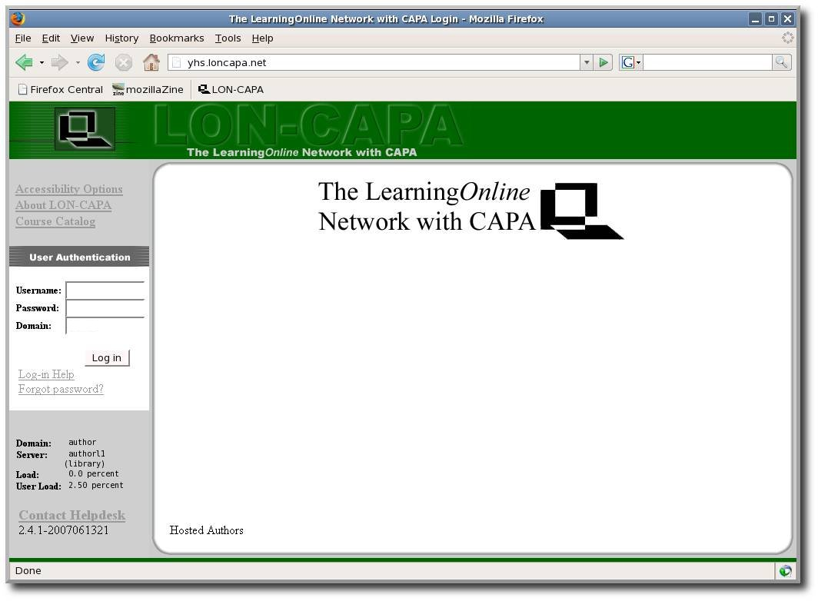Illustration 1: The LON-CAPA login screen.
Press “Log in” and if your login was correct and successful, you will see the “Successful Login” greeting page (shown in Illustration 2).
USERNAME: | ____________________ (write down here)
PASSWORD: | Given by your instructor, NEVER WRITE THIS DOWN
DOMAIN: | Same as the above “DOMAIN” box
QUICK TIP:
Forget your password? Assuming you have entered an email address into the system (see Section d), clicking on the “Forget Password?” link on the login screen can help you reset your password.
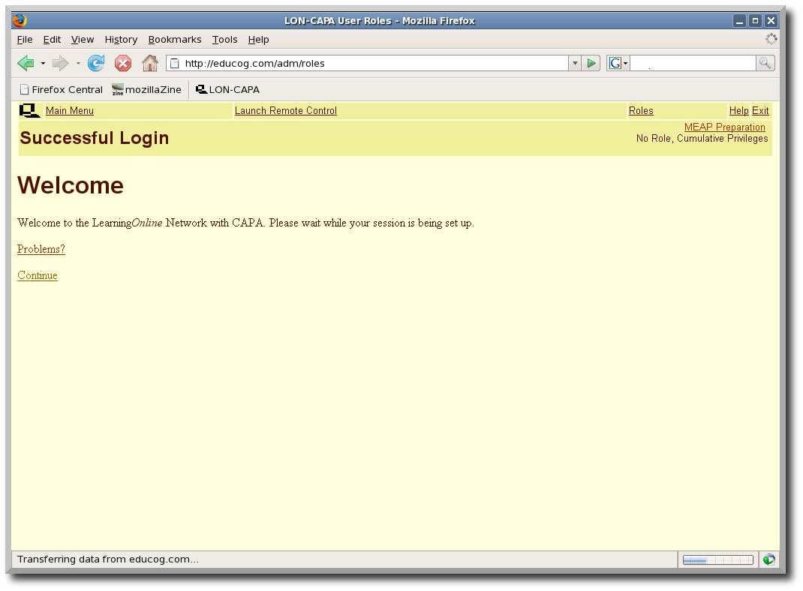Illustration 2.: The LON-CAPA Successful login screen.

d. Specifying an Email Address In Case You Lose Your Password
After successfully logging in, you will see one of two things, depending on how many LON-CAPA courses you are enrolled in:
Only One Course: | You will automatically enter and be taken to the first page for your course.
More than One Course: | You will be taken to a “Courses” screen where you can pick which course you enter.
The first time you log in, however, you should specify an email address in case you ever lose or forget your password.
To do this, first click on the “Main Menu” link at the top of the page – for more information on what many of these icons and links do, see section g – and click on the icon entitled “Set my user preferences”, and then “Change Message Forwarding and Notification Email Addresses.”
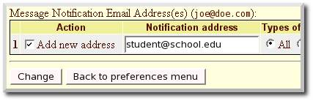Illustration 3: Adding a new email address
Enter your email address into the box for Message Notification (see Illustration 3) and press the “Change” button.

e. Doing Your Homework and Viewing Resources
QUICK TIP:
You can view your previous submissions for a problem by clicking on the “Previous Tries” link next to the submit button.
The syllabus (see Illustration 4) is a document where you can easily see data such as class expectations, grading scale, a way to contact the course coordinator (your instructor), and much more. It also provides a way to subscribe to RSS feeds and podcasts containing course announcements and other content (see Section i for more information).
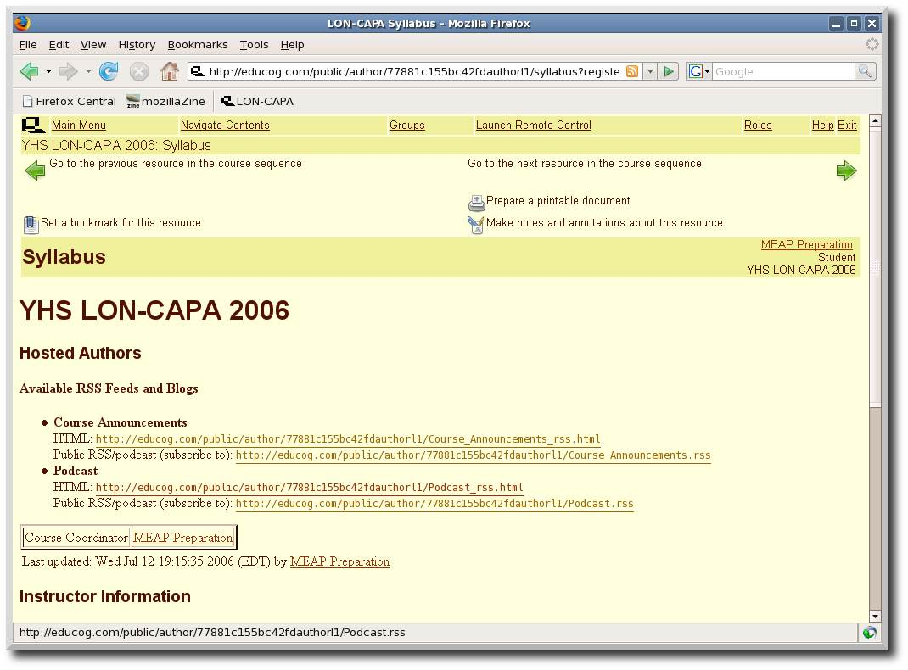Illustration 4.: The LON-CAPA syllabus page.
To view your course's content, such as homework problems and resource pages, press “Navigate Contents” at the top of the page (circled in red in Illustration 4).
The typical “Navigate Contents” page consists of a listing of folders and resources. When you click on, or expand, a folder, you will see different icons next to each resource. The two most common icons are , which stands for a problem/question, and , which represents an HTML web page (see Illustration 5).
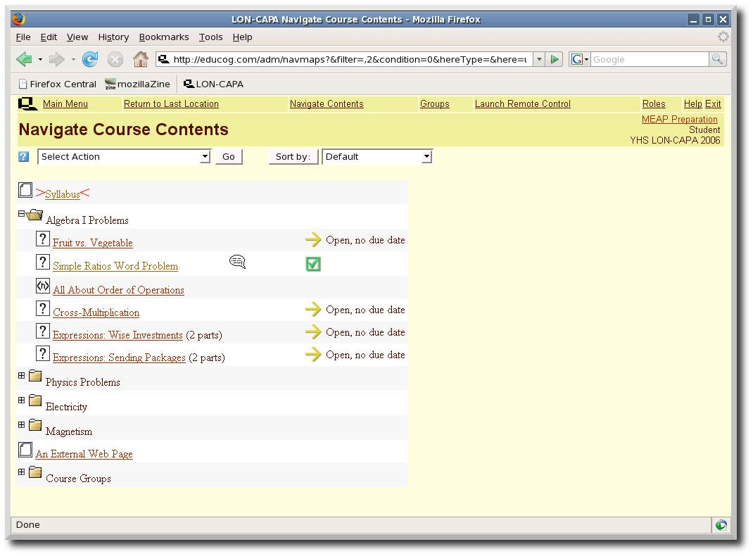Illustration 5.: “Navigate Contents” screen.
An HTML page may be information pages, instructions on concepts, interactive Java applets, or possibly anything else that you may see on a web page. Finally, a speech bubble near the right of a problem’s row means that some sort of discussion has been posted on the problem’s page.
If you click on the link for an individual problem, you will see
a page which looks like Illustration 6.
There are many types of problems you might encounter in LON-CAPA. This example is a matching problem, where you classify foods as a fruit or vegetable. However, you may encounter multiple choice, click on an image, essay, numerical, and formula response questions, just to list a few.
When you have filled in an answer for a question, press the “Submit Answer” button.
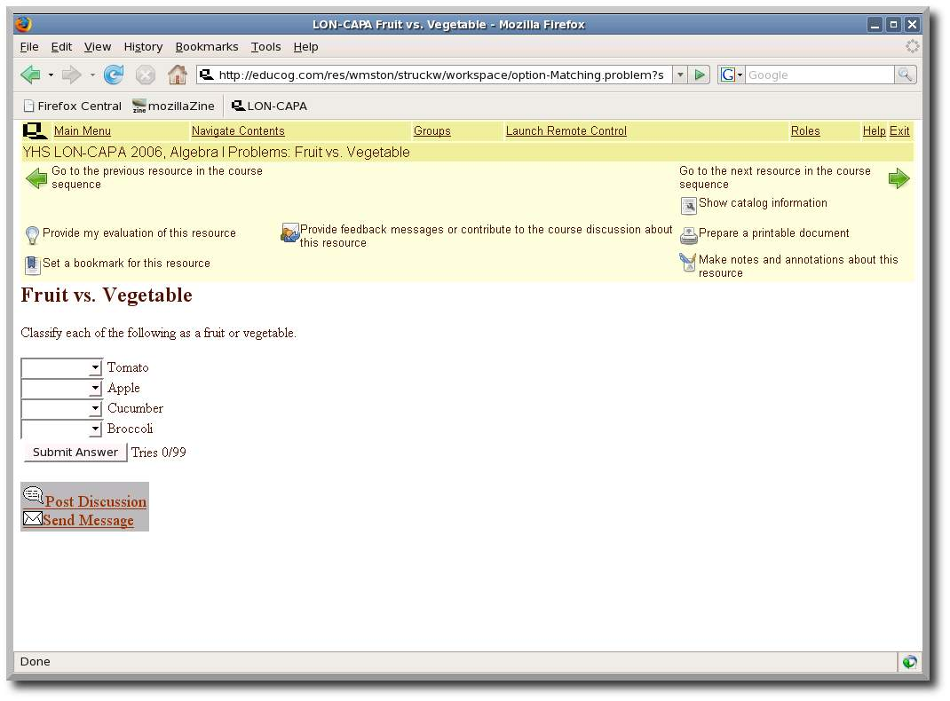Illustration 6.: A sample LON-CAPA problem.
If you are incorrect, the answer boxes are still there, but you will see that you have used one of your tries. (See Illustration 7.)
If you get it correct, the answers will appear and the “Submit Answer” button will disappear. (See Illustration 8.)

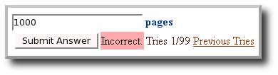Illustration 7.: Sample incorrectly answered question. | 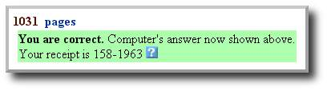Illustration 8.: The same question as before, but answered correctly.
If you use up all of your tries for a problem without answering correctly, the “Submit Answer” button will disappear permanently and you will not receive credit for the problem.

When working with a numerical and/or formula response, keep these things in mind:
For Scientific Notation: If you are submitting an answer in scientific notation, enter it as you would in your graphing calculator.
Example: 1.76 x 10⁵ would be entered as “1.76E5” (minus the quotes).
For Units required: Many problems, especially in science, require a unit in your answer. Note that the system uses order of operation for its units.
QUICK TIP:
You can give yourself scratch space on your printouts by adjusting the margins in the Print Options pages.
Order of operation:
Please excuse my dear aunt Sally…
P – Parentheses
E – Exponents
MD – Multiplication and division, left to right
AS – Addition and subtraction, left to right
Example: 1895 meters squared per second (m²/s) would be entered as “1895 m^2/s” (minus the quotes). Remember that for this, with order of operations, “m^2/s” is the same as “(m^2)/s” but different than “m^(2/s)”.
For Formula Responses: Some problems will require a formula in response, such as . To submit the answer above, use the correct order of operations and enter:
(5/2)*x^2 + 6*y

To move between resources, press the [] or [] icons in the top portion of your screen.

f. Printing Using LON-CAPA
Sometimes it becomes necessary to print out your homework. LON-CAPA can easily make a neat and tidy PDF file which can be printed. To do this, first of all, you will need a program to open PDF files; the most common of these programs are Adobe Reader and Adobe Acrobat. If you do not have either, or your version is outdated, go to the following site to download Adobe Reader for free:
http://www.adobe.com/reader
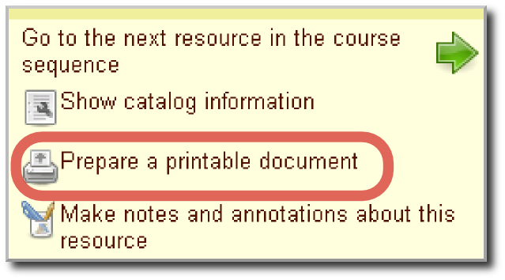Illustration 9.: The location of the Print icon.
When you would like to print something, click the [] icon in the top right portion of the page (see Illustration 9). The print menu will then appear, with the following options:
Print the problem you were just working on: This will just print the one problem you were last on when you hit the print button.
Print the problems from [folder name]: This will give you a selection of problems to print from the folder you were in when you hit the print button. Note that this will only print the problems, not the HTML pages or other documents.
Print the resources from [folder name]: This will give you a selection of all documents to print from the folder you were in when you hit the print button. This does include HTML pages and other documents.
Beneath the options for what to print are choices for what paper alignment (portrait or landscape), the number of columns in your printout, and the paper type (common printer paper is “Letter” size). Press “Next”.
The system will then create a printable PDF file for your use. When it is complete, click on the link to download/open the file.
In Adobe Reader, you may save a copy of the PDF file for future use, or you just may hit the print button once open.
If LON-CAPA cannot make the PDF file, it will take you back to the “Select” problems or resources pages, and tell you which problem/resource it had trouble printing. Unselect that problem/resource and try again.

g. Discussion and Communication
LON-CAPA has many ways of enabling you to communicate with your peers. The following are just a few ways you can get in touch with peers and instructors:

Discussion Boards
On many problems, there are opportunities to use a thread-based communication system, where you can post questions, comments, etc. and your peers can reply or write their own messages regarding the problem. To post a discussion, click on the “Post Discussion” bubble at the bottom of a problem. (See Illustration 10.) If a discussion has new posts, the speech bubble will appear next to a resource's listing on the “Navigate Contents” screen.
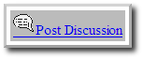Illustration 10: Post Discussion Button
Illustration 11.: Send Message Button
When you post, you may post under one of the following:
Post Anonymous: Your name will not be included with the post, but still viewable by course faculty. In your preferences (see section h), you can give yourself a screen name to use when you post anonymously.
Post: Your name will appear next to your post.

Communication (E-Mail) and Messages to Your instructor
LON-CAPA also has its own internal mail system. Often times your course coordinator or instructor will send you messages through this system.
To send a private e-mail message to your instructor or TA about a specific resource, or for general questions on course policy, press the “Send Message” button that appears at the bottom of a problem/resource (see Illustration 11).
Certain messages, dubbed “Critical Messages” will require you to acknowledge receiving the message before continuing. To access the LON-CAPA communication system, press the [] icon on the Main Menu.

h. Main Menu and Preferences of LON-CAPA
By selecting “Main Menu” at the top of the screen, a screen appears with several options that are very useful to any LON-CAPA user to know. Some of them include:

View extra documents included with a course
By clicking the this icon, you can view extra supplemental documents such as PDF files, web pages, PowerPoint presentations, or Word documents that your instructor has chosen to include in the course.

 View grades
This screen gives you a display of your current grades, out of a possible number of points.

 View and edit your Portfolio
(See Illustration 12.) LON-CAPA has an on-line portfolio system that allows students to upload files that can be submitted for credit, published to the public, and shared with other users on the system.
Uploading a File: To upload a file to your portfolio, click on the “Browse...” button to find the file on your local file system, then press “Upload” to upload the file.
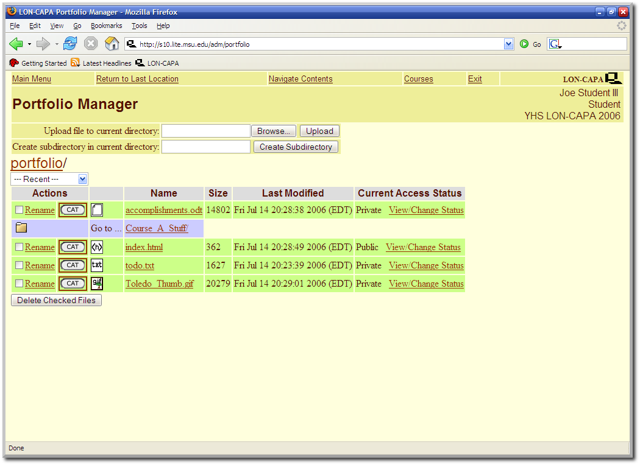Illustration 12: LON-CAPA Portfolio Interface
View/Change Status: To make a file public, or accessible only to users with a certain passphrase, press the “View/Change Status” link and follow the instructions.
Drop Boxes:
You may encounter problems in LON-CAPA where a file submission is required. In this case, you can either upload a file from your machine to submit, or submit a file from your portfolio. Your instructor will be able to hand back a commented/edited file directly to your portfolio if you choose the option to submit the file from your portfolio.

 View Course Groups
This button lets you view groups in your course. Groups is a feature in which your class may be split into multiple parts (such as lab groups, etc.). Depending on the options specified by your instructor, a group may have the following options and features:
Discussion Boards: Specialized discussion boards designed only for group access. These can appear on your “Navigate Contents” page under the folder name “Course Groups”.
File Repository: A special interface, similar to your own personal portfolio, where group members can upload and access files.
Membership Roster: View the members in your group.
For more information about groups, check with your instructor.

 Edit User Preferences
In the preferences menu, you can do the following things (and more):
Change Password: Self-explanatory, highly recommended for new users to change their passwords from the default
Change Screenname: On discussion posts and the chat line, you can change the names that appear when you post a message.
Change Message Forwarding and Notification Options: Enter your email address here to get an email letting you know someone sent you a message in LON-CAPA. Remember, if you tell LON-CAPA your email address, you can use it to recover a lost password (see section d).
Edit the “About Me” Personal Information Screen: Each user gets their own “About Me” page to describe himself/herself. Edit it here.
Change Color Scheme: Here, you can play with the colors of the LON-CAPA system and personalize it to your own tastes.
Change Language: Here you can select the language that LON-CAPA presents you (only the user interface, not the actual homework problems) Useful for foreign exchange students.
Change WYSIWYG Editor Preferences: Pronounced “Whizzy-wig”, and short for “What You See Is What You Get”, this allows for bold, underline, etc. on your messages (or you can choose just plain text).
Launch Remote Control: If you prefer the ability to navigate the LON-CAPA system in a separate browser window while you work, just click the text “Launch Remote Control” on the top navigation bar. The use of the remote control may conflict with many pop-up blockers. See the documentation of your browser and/or pop-up blocking plug-in for information on how to disable it. To return from remote control mode back to the default navigation system, simply close the remote control.

i. Additional LON-CAPA Features

1. Course Feeds and Podcasts
Feeds, also known as RSS (Really Simple Syndication), are a way of delivering packets of information to a user in an automated manner. By subscribing to a feed, you receive new items associated with that feed for as long as you subscribe. Often times, feeds are used as a way to update subscribers of changes to a website.
In LON-CAPA, feeds can be used in a variety of methods. Feeds may contain such things as: course announcements, notes from the professor, or podcasts. A podcast is a special type of feed in which audio or video files are included with a feed.
Subscribing to Course Feeds
How does one subscribe to a feed, especially a LON-CAPA feed? You can see a list of a course's feeds by going to a course's Syllabus page. To just view the content of the feed, click the link entitled “HTML”. To subscribe to a feed, click on the second link entitled “RSS/Podcast” All major browsers currently support feeds and/or podcasting, with the exception of:
- Internet Explorer 6
- Mozilla Firefox (no podcasting support)
External services such as Google Reader, iTunes, and other programs provide support for podcasts and/or feeds. For more information on how to subscribe to these feeds in other programs, read the help documents associated with those programs.

Creating your Own Feeds
On the main menu, there is a link to “Edit Blogs, RSS Feeds, and Podcasts.” Clicking this link enables you to create your own feeds, with whatever content you choose. These feeds will appear on your “About Me” page, accessible by clicking your name in the upper right corner of the page.

j. Quick Troubleshooting Guide
If your login fails...
Make sure you are on the correct domain and your username and password are correct. Make sure JavaScript and cookies are enabled on your system. (See section b.)
If you forget your password...
On the login page, click on the “Forgot Password?” link. Please note that an email address must be on file with the system in order to use this feature. (See section d.)
If your document won't print...
If the print job fails, LON-CAPA will take you back to the “Select” problems or resources pages, and tell you which problem/resource it had trouble printing. Unselect that problem/resource and try again. (See section f.)
If a Java applet fails to load...
Make sure Java is enabled in your browser (see section b). If this doesn't work, see your instructor.

k. More Online Help
To get help on the LON-CAPA system beyond what this document covers, look for blue “?” buttons, which contain more information about a certain topic. (See Illustration 14.) Additional help is available if you click the Help link on the upper-left-hand corner of the Inline Menu which appears on every screen in LON-CAPA.
Illustration 14.: Blue help links found throughout LON-CAPA.
If this fails, you can try to contact your instructor, by phone, email, or some other method.

Last updated September 12, 2007

